Content Intake Form Instructions

- Please delete and replace all placeholder text in the intake form with your own content. Your content will be displayed as submitted, so please make sure it looks exactly how you want it to appear publicly. Please send back your intake form as a word document.

- Please include image thumbnails within your text as placeholders only. This allows us to know your requested placement of each image, along with the corresponding image captions. Please send final high resolution images as email attachments.

- Requested Email Subject Line for Akimbo Emails only:
Typical formatting is:
- Artist Name: Exhibition Title @ Organization or Venue Name, City
- Event Type: Event Title @ Organization or Venue Name, City
- For more examples, please visit Akimbo Content Writing Tips

- Image Placement: Place images evenly throughout your text to create a balanced layout between visuals and written content. Maximum of four images. Logo(s) count towards the total image count. Logo(s) are placed at the bottom along with the footer information.

- Selecting Your Images: Please avoid using images that contain text or logos as this can create accessibility barriers and can increase the likelihood of your content being flagged as spam, reducing its reach and effectiveness. Visit Akimbo Content Guidelines for more details.

- Multiple Logos: If you need to use more than one logo (e.g. sponsorship logos), please combine and arrange all logos into a single image file (a logo block). This way, your combined logos will count as just one of your four allowed images.

- Image Captions/Credit: Place these below each image in the form. Avoid putting image captions/credits in the image filename. Typical formatting is:
- Artist Name, Artwork Title, Date, Medium, Dimensions
- Image/Photo: Name of person to be credited
- For combined/collaged images use this formatting:
Images (left to right): Artist Name 1, Artwork Title 1, Date, Medium, Dimensions. Image/Photo: Name of person 1; Artist Name 2, Artwork Title 2, Date, Medium, Dimensions. Image/Photo: Name of person 2.

- Accessibility: Please specify whether the organization or venue is fully, partially, or not accessible. If you have additional information to share, adding a link to a relevant page on your website is often very helpful.

- Image Descriptions: Image descriptions are visible, detailed explanations of an image that provide extra context to help all users understand the visual content of an image. Maximum 280 characters. Image descriptions are not image captions/credits. For image captions/credits instructions, please refer to #5 above.

- Hyperlinks: Please avoid placing hyperlinks on secondary titles or subheadings. Instead, include hyperlinks within the main body text of your paragraphs. A maximum of 15 hyperlinks may be used.

- Intake Form Example: View a filled out intake form for your reference on page 7 below (demonstration only).

- For further details on submitting content, please visit Akimbo Content Guidelines and Content Writing Tips.

Intake Form

Requested Email Subject Line Here (for Akimbo Emails only):

Festival / Event / Workshop / Series Title (max 100 characters)
Subtitle and/or Organization Name (Optional)

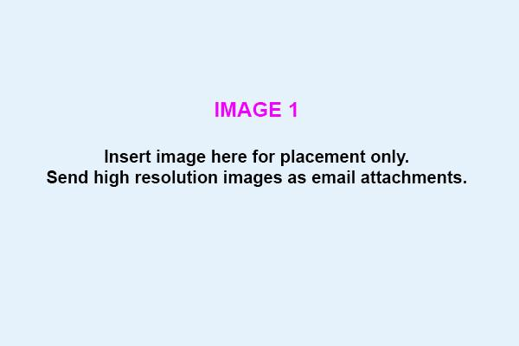

Image caption/credit: Add image caption/credit text here

Secondary Title or Heading

Programming Dates (Optional)
Venue / Location Name, City (Optional, include full address at the bottom in footer)
Hyperlink (for online programs)

Insert 2 – 4 paragraphs here (e.g. event / series introduction)

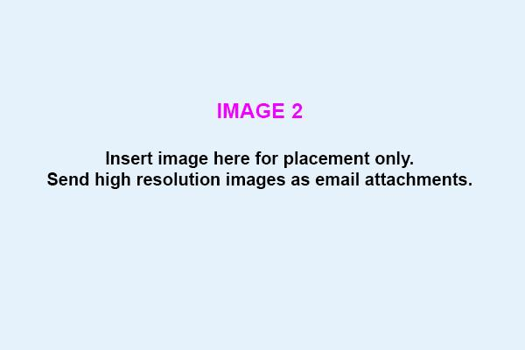

Image caption/credit: Add image caption/credit text here

Subheading (Optional)

Event Title Here
Date/Time (+ time zone for online programs)
Location (only if required)
Additional details (e.g. registration link)
Insert paragraph here
Event Title Here
Date/Time (+ time zone for online programs)
Location (only if required)
Additional details (e.g. registration link)
Insert paragraph here

Event Title Here
Date/Time (+ time zone for online programs)
Location (only if required)
Additional details (e.g. registration link)
Insert paragraph here

Continue events as required…

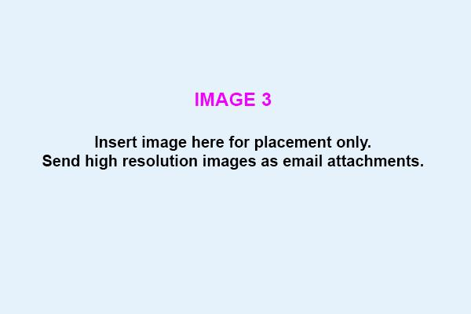

IImage caption/credit: Add image caption/credit text here

About Organization Name
Insert paragraph here

Land acknowledgement here (Optional)

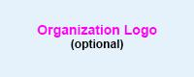

Organization Name
Location Address
Website URL
Email
Phone Number
Facebook @abcdef
Instagram @abcdef
X/Twitter @abcdef

Accessibility:
Organization Name is [fully / partially / not] accessible. For more information, [visit here].

Image Descriptions: (Optional)
1. Add description for image 1 here
2. Add description for image 2 here
3. Add description for image 3 here

_________________________________________________________________

Alternative Logo Option: In place of a single logo, you can create a logo block.

Sponsor acknowledgement text (optional)

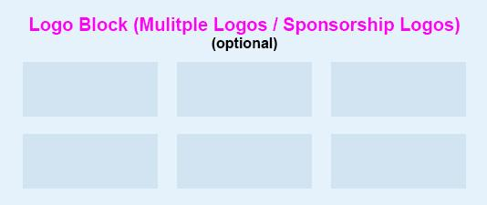

Example Intake Form Filled In (for demonstration only)

Art in the Park: Summer Festival of Creativity
Presented by Riverside Arts Collective

Photo: An Artist

A Celebration of Outdoor Art, Performance, and Local Makers

June 13 – 15, 2025
Riverside Commons, Meadowbrook

Art in the Park: Summer Festival of Creativity brings together the community for a vibrant weekend of outdoor art, interactive experiences, and local talent. Set in the scenic Riverside Commons, this festival invites visitors of all ages to explore large-scale sculpture installations, participate in hands-on performances, and browse a bustling arts market featuring makers from across the region.

Whether you’re an art enthusiast, a family looking for a fun day out, or simply curious about creative happenings in Meadowbrook, Art in the Park promises something for everyone. Enjoy live demonstrations, meet the artists, and discover the stories behind each piece in a relaxed, welcoming environment.

Art in the Park: Summer Festival of Creativity 2024

Festival Highlights

Nature Reimagined
June 13 – 15, 10am – 7pm
Free
Stroll through a curated outdoor exhibition featuring monumental sculptures by regional and national artists. This year’s theme, Nature Reimagined, explores the intersection of art and environment, with pieces crafted from reclaimed wood, metal, and stone.

Interactive Performance: The Living Canvas
June 14, 2 – 4pm
Great Lawn Stage
Free | Registration Required

Join performance collective MoveMe for an immersive, participatory event where the audience becomes part of the art. Through guided movement and collaborative painting, festival-goers of all ages can help create a giant mural on the lawn. No experience necessary—just bring your curiosity.

Arts Market
June 13 – 15, 10am – 6pm
Open to the public
Browse and shop from over 40 local artists, designers, and craftspeople. Find ceramics, jewelry, textiles, prints, and more. Many vendors offer live demonstrations and custom commissions. Support independent artists and take home a unique piece of the festival.

Art Market 2024. Photo: Riverside Arts Collective

About Riverside Arts Collective
Riverside Arts Collective is a vibrant nonprofit dedicated to enriching the Meadowbrook community through dynamic arts programming. Their flagship event, Art in the Park, is an annual summer festival that celebrates creativity in all forms—from large-scale outdoor sculptures and interactive performances to a lively arts market featuring local makers. This inclusive festival fosters connection, inspiration, and appreciation for the arts in a welcoming, family-friendly setting.

We gratefully acknowledge the Indigenous nations and people for their guardianship of this land. We’d also like to remind and reaffirm, as Canadians, our accountability to these Indigenous nations, and to all Indigenous peoples and communities, and to care for this land, its waters, and all of the biodiversity. All people who live and work here are responsible for honouring this place, people, and treaties, in the spirit of peace, friendship, and respect.

Riverside Arts Collective
123 Avenue Street
Meadowbrook
riversideartcollect.ca
info@riversideartcollect.ca
123-456-7890
Facebook @riversideartcollective
Instagram @riversideartcollective
X/Twitter @riversideartcollective

Accessibility:
Riverside Commons is fully accessible. For more information, visit here.

Image Descriptions:
1. A photograph of the 2024 Art in the Park: Summer Festival of Creativity. Festival attendees interact with the outdoor art exhibition.
2. A photograph of a large group of people enjoying and interacting with an outdoor art exhibition on a sunny day.
3. A photograph of artists showcasing their work at the Art in the Park: Summer Festival of Creativity.

