Content Intake Form Instructions

- Please delete and replace all placeholder text in the intake form with your own content. Your content will be displayed as submitted, so please make sure it looks exactly how you want it to appear publicly. Please send back your intake form as a word document.

- Please include image thumbnails within your text as placeholders only. This allows us to know your requested placement of each image, along with the corresponding image captions. Please send final high resolution images as email attachments.

- Requested Email Subject Line for Akimbo Emails only:
Typical formatting is:
- Artist Name: Exhibition Title @ Organization or Venue Name, City
- Event Type: Event Title @ Organization or Venue Name, City
- For more examples, please visit Akimbo Content Writing Tips

- Image Placement: Place images evenly throughout your text to create a balanced layout between visuals and written content. Maximum of four images. Logo(s) count towards the total image count. Logo(s) are placed at the bottom along with the footer information.

- Selecting Your Images: Please avoid using images that contain text or logos as this can create accessibility barriers and can increase the likelihood of your content being flagged as spam, reducing its reach and effectiveness. Visit Akimbo Content Guidelines for more details.

- Multiple Logos: If you need to use more than one logo (e.g. sponsorship logos), please combine and arrange all logos into a single image file (a logo block). This way, your combined logos will count as just one of your four allowed images.

- Image Captions/Credit: Place these below each image in the form. Avoid putting image captions/credits in the image filename. Typical formatting is:
- Artist Name, Artwork Title, Date, Medium, Dimensions
- Image/Photo: Name of person to be credited
- For combined/collaged images use this formatting:
Images (left to right): Artist Name 1, Artwork Title 1, Date, Medium, Dimensions. Image/Photo: Name of person 1; Artist Name 2, Artwork Title 2, Date, Medium, Dimensions. Image/Photo: Name of person 2.

- Accessibility: Please specify whether the organization or venue is fully, partially, or not accessible. If you have additional information to share, adding a link to a relevant page on your website is often very helpful.

- Image Descriptions: Image descriptions are visible, detailed explanations of an image that provide extra context to help all users understand the visual content of an image. Maximum 280 characters. Image descriptions are not image captions/credits. For image captions/credits instructions, please refer to #5 above.

- Hyperlinks: Please avoid placing hyperlinks on secondary titles or subheadings. Instead, include hyperlinks within the main body text of your paragraphs. A maximum of 15 hyperlinks may be used.

- Intake Form Example: View a filled out intake form for your reference on page 6 below (demonstration only).

- For further details on submitting content, please visit Akimbo Content Guidelines and Content Writing Tips.

Intake Form

Requested Email Subject Line Here (for Akimbo Emails only):

Call for Submissions: Project Title

Subtitle (Optional)



Image caption/credit: Add image caption/credit text here

Secondary Title or Heading

Submission Deadline: Month, Day, Time + Time Zone (e.g. 11:59pm PT, MT, CT, ET, AT, NT)

Insert project summary paragraphs here

Project Requirements

Inset paragraphs or lists here

Eligibility

Insert paragraphs or bulleted lists here

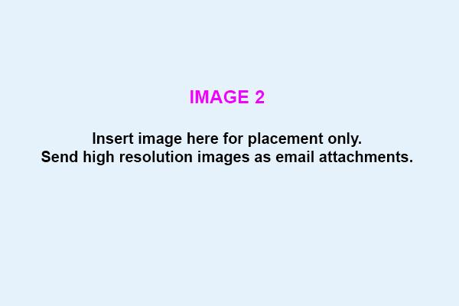

Image caption/credit: Add image caption/credit text here

Compensation

Insert details here

Selection Process

Insert paragraphs or bulleted lists here

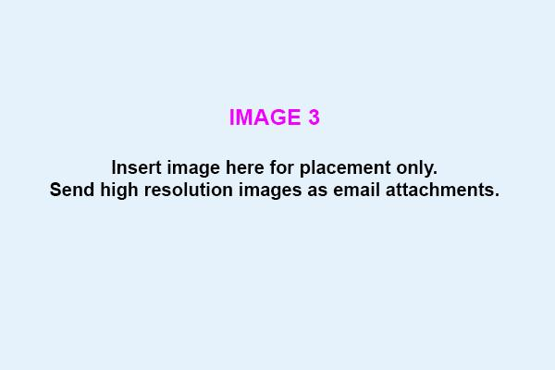

Image caption/credit: Add image caption/credit text here

Submission Requirements

Insert paragraphs or bulleted lists here

How to Submit

Insert details here, including email address or web page/portal to submit applications

Submission Deadline: Month, Date #, Year

For additional information or questions, please contact:
Contact Name
Contact email address | phone number

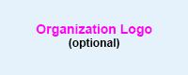

Organization Name
Location Address
Website URL
Email
Phone Number

Facebook @abcdef
Instagram @abcdef
X/Twitter @abcdef

Accessibility:
Organization Name is [fully / partially / not] accessible. For more information, [visit here].

Image Descriptions: (Optional)
1. Add description for image 1 here
2. Add description for image 2 here
3. Add description for image 3 here

Example Intake Form Filled In (for demonstration only)

Call for Expressions of Interest: Public Art Mural, City of Dunesbreeze

City of Dunesbreeze. Photo: A. Sky

Call to Artists: Public Art Mural for the City of Dunesbreeze

Submission Deadline: JUne 25, 2025, 11:59pm ET

Dunesbreeze is a welcoming, mid-sized city celebrated for its vibrant neighborhoods, diverse community, and commitment to fostering creativity in public spaces. The city’s downtown core, known for its blend of historic charm and modern amenities, serves as a lively gathering place for residents and visitors alike. Over the past decade, Dunesbreeze has invested in cultural initiatives that highlight both its rich history and its forward-looking spirit.

As part of its ongoing public art program, the City of Dunesbreeze seeks Expressions of Interest (EOI) from artists and artist teams for a new signature mural in the heart of downtown. This mural will become a landmark feature, enlivening the streetscape and serving as a source of pride and inspiration for the entire community. The city is committed to supporting innovative, inclusive, and durable public art that reflects Dunesbreeze’s unique character and values.

Project Requirements

The City of Dunesbreeze invites artists and artist teams to submit Expressions of Interest (EOI) for the creation of a large-scale public art mural in the heart of downtown. The mural should celebrate the city’s vibrant culture, reflect its diverse community, and enhance the public realm with creativity and color.

- The mural must be original, designed specifically for the designated wall, and suitable for outdoor display.
- Proposals should include a concept statement, preliminary sketches or renderings, and a clear description of the intended theme.
- The artwork must be durable, weather-resistant, and safe for public interaction.
- All materials used must be non-toxic and suitable for long-term outdoor exposure.
- The mural must not include advertising, offensive content, or direct political messaging.
- Artists are responsible for installation in coordination with city staff and must adhere to all municipal bylaws and safety standards.
- The final mural dimensions are approximately 30 feet wide by 15 feet tall.

Eligibility

This EOI is open to emerging artists and artist teams who are interested in developing their skills and experience in public art. We strongly encourage applications from individuals and groups from diverse backgrounds, including those who may not have previously completed large-scale mural projects.

- Open to residents of Dunesbreeze and the surrounding region.
- Both individuals and artist teams are welcome to apply.
- Previous experience with public art or murals is not required; however, applicants should demonstrate artistic promise and a clear interest in community-based art.
- City employees and members of the selection committee are not eligible to apply.
- Artists must be available for installation during the scheduled project period.

City of Dunesbreeze. Photo: A. Sky

Compensation

The selected artist or team will receive a fee of $15,000 + HST

Selection Process

This is a two-stage process. In Stage One, artists submit an Expression of Interest outlining their qualifications and initial concept. A shortlist of up to three finalists will be selected to advance to Stage Two, where each will be invited to develop a more detailed proposal and present their concepts to the selection committee.

In Stage Two, finalists will receive a small honorarium for their detailed proposals. The final selection will be made based on artistic merit, feasibility, and alignment with project goals. The successful artist will then work with city staff to finalize the design and oversee installation.

Stage One: Review of EOIs and shortlisting by a panel of arts professionals and city representatives.

Stage Two: Finalist presentations and interviews.

City of Dunesbreeze. Photo: A. Sky

Submission Requirements

Artists must submit their EOI electronically as a single PDF document (maximum 10MB). Incomplete or late submissions will not be considered. All materials should be clearly labeled and organized.

- Completed submission form with contact information.
- Artist statement (max 500 words) describing your interest and approach to the project.
- Up to 5 images of previous relevant artwork (JPEG or PDF).
- Current artist CV or resume (max 3 pages).
- Brief project timeline and budget outline.
- Names and contact information for two professional references.

Visit the website for a complete list of submission requirements.

How to Submit

Please review the full details and submit your Expression of Interest via the online submission form on the City of Dunesbreeze website.

Submission Deadline: June 25, 2025, 11:59pm ET

For additional information or questions, please contact:
A. River, Public Art Coordinator
publicart@citydunesbreeze.ca | 123-456-7890

City of Dunesbreeze
123 Avenue Street
Dunesbreeze, ON
citydunesbreeze.ca
info@citydunesbreeze.ca
123-456-7890

Facebook @dunesbreeze_fb
Instagram @dunesbreeze_ig
X/Twitter @dunesbreeze_x

Accessibility:
Organization Name is fully accessible. For more information, visit here.

Image Descriptions:
1. An aerial photograph of the City of Dunesbreeze showing the downtown main street lined with trees, shops, and cafes.
2. Street-level wide photograph of the mural site in downtown Dunesbreeze. A large, brick wall on a community building faces a plaza with benches and planters.
3. Close-up photograph of the designated mural wall location showing a smooth brick surface approximately 30 feet wide by 15 feet tall.

